**Experimentation and Results**

We have tested our program for the following test cases -

1. **Line of text terminated by a newline**

For this use case, we have the client enter a line of text and then click enter. This message is sent to the server and the server echoes it back to the client.

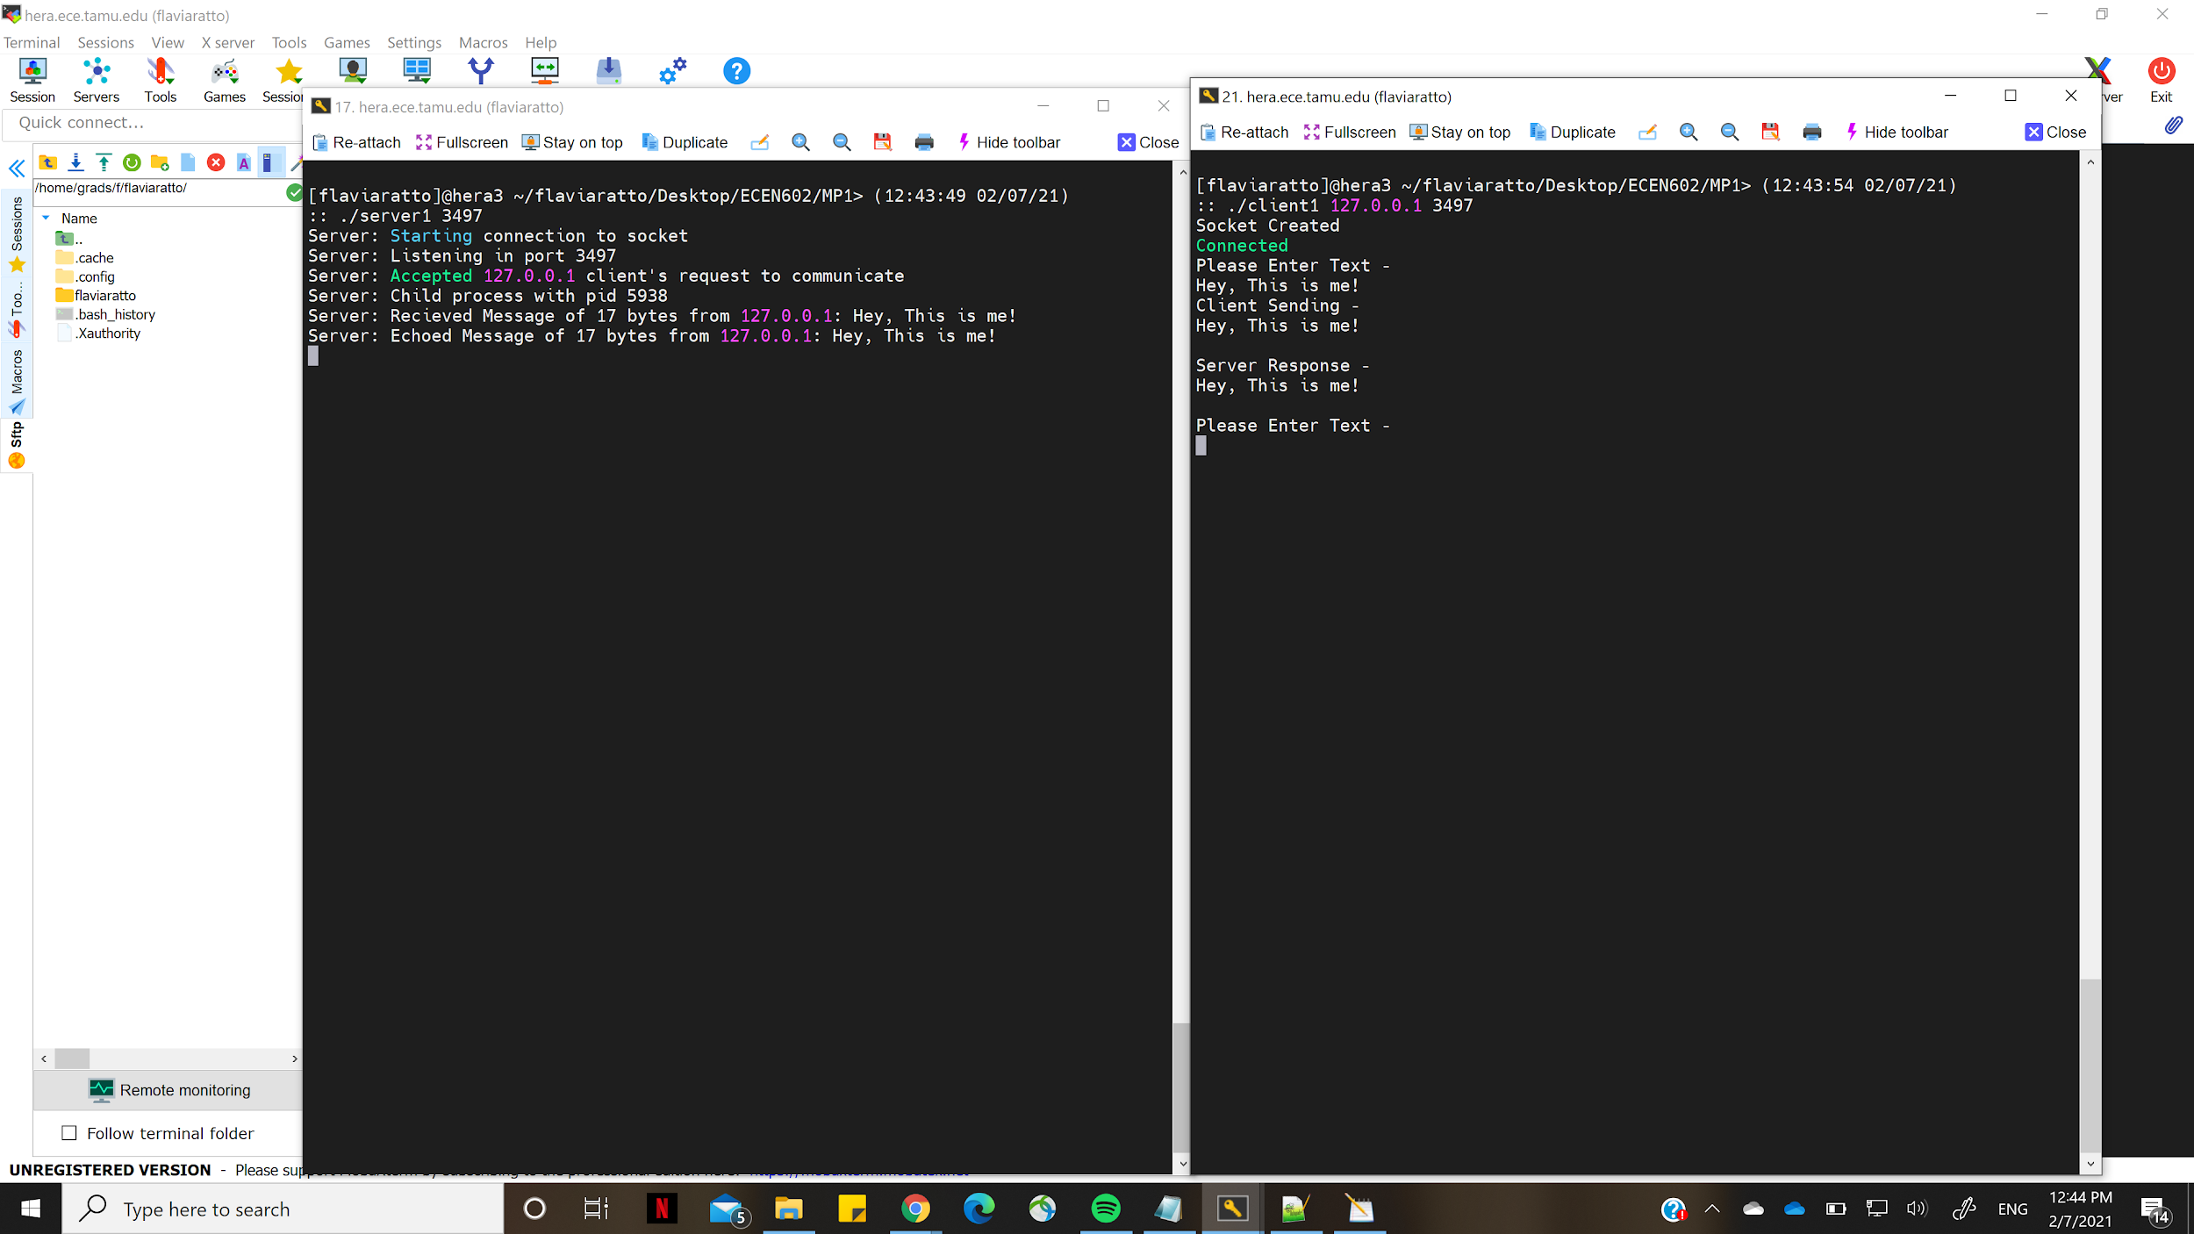

1. **Line of text the maximum line length without a newline**

In this use case, we have the client send a very long text to the server. This text is sent to and received by the server as a stream of packets.

We are assuming the maximum line length that can be transmitted is 100. The maximum size of the packets sent is 100 bytes. If the message to be transmitted is more than 100 bytes, the data is sent in packets of 100 bytes.

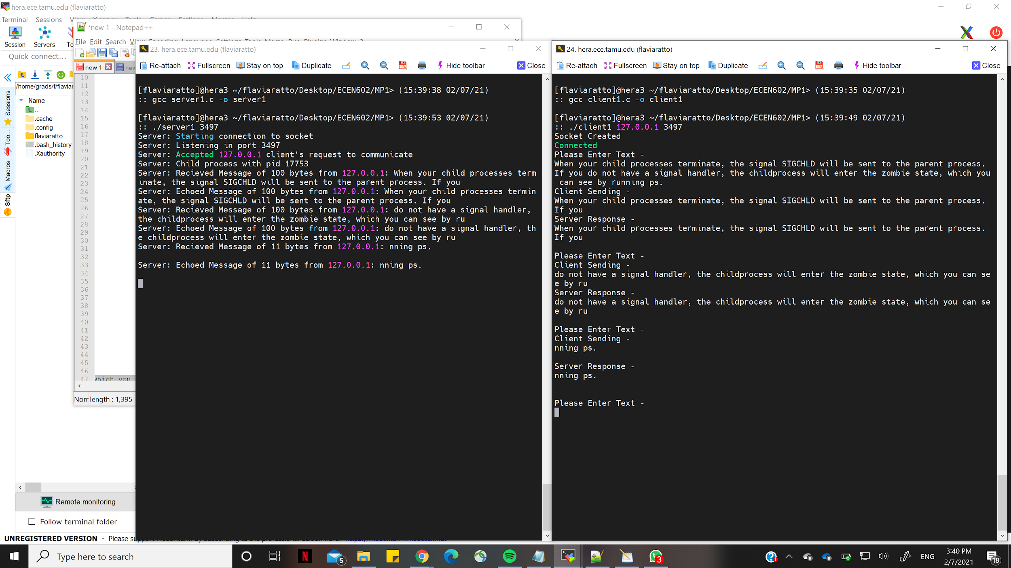

1. **Line with no characters and EOF**

In this use case, when we enter no text and click enter, we do not receive any text on the client side. When whitespace or tab space is entered along with an EOF, the server will consider this as “no text” and client side will not receive anything back from the server. The client will proceed to sending another message to the server by prompting the user to enter a message in the command line.

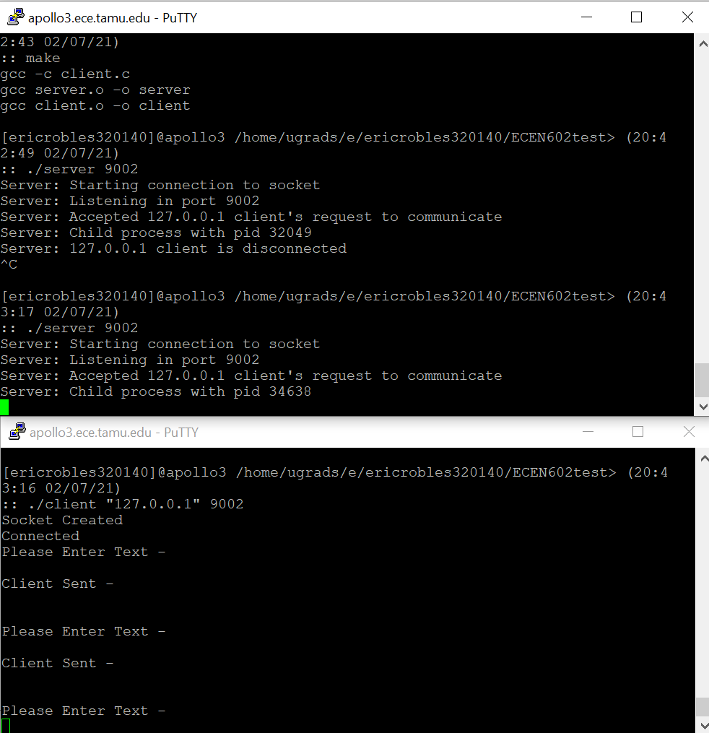

1. **Client terminated after entering text**

In this use case, we type a text and hit CTRL+D twice. The client detects EOF and terminates the connection. The server reads the EOF notification and closes its socket.

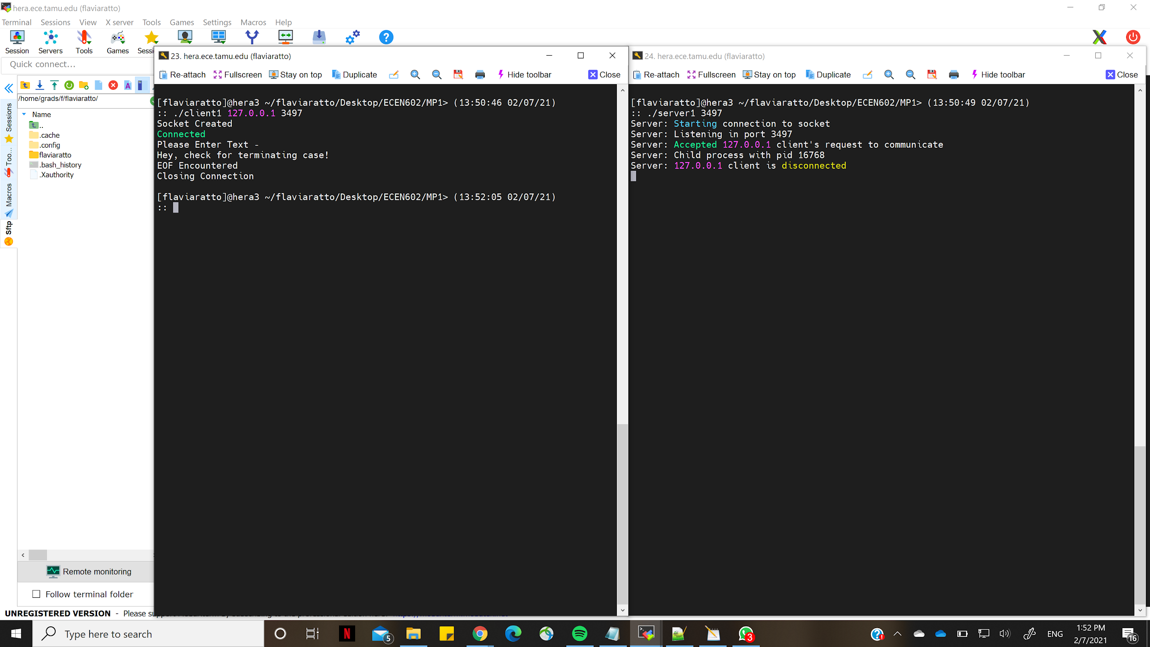

1. **Three clients connected to the server**

Here, we have three clients connected to the same server and sending messages to it. The server supports all the connections and sends the corresponding response back to the client

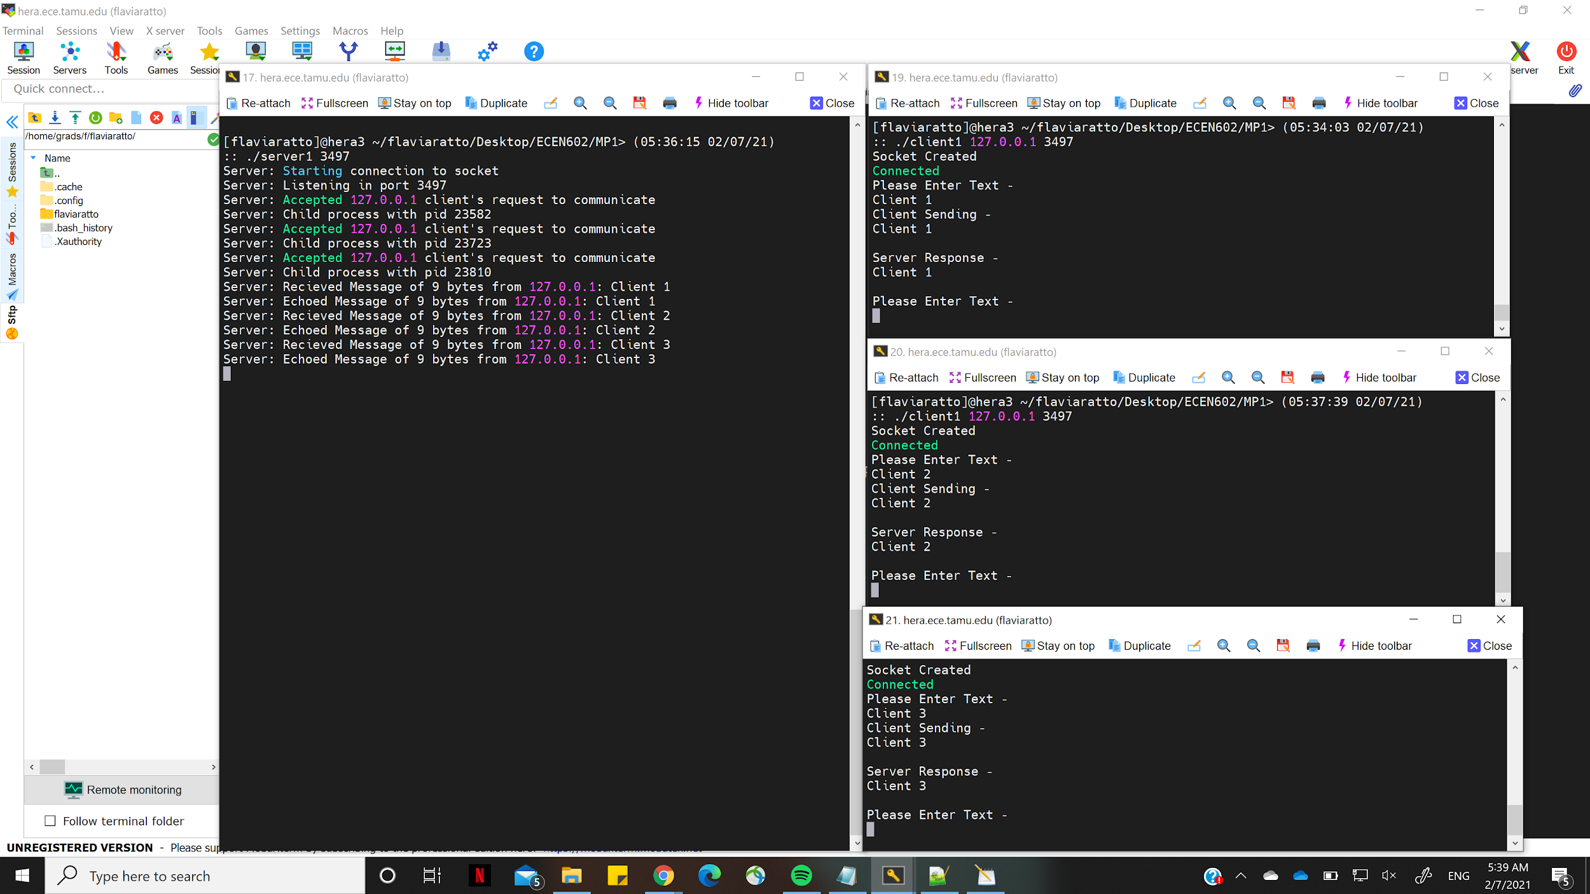

Clients have terminated their connection by hitting CTRL+D.

